 | 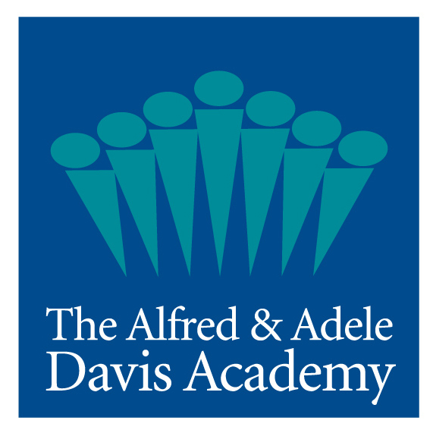
DAVIS ACADEMY MAKES AJC TOP WORKPLACE LIST FOR THIRD YEAR
Atlanta, GA – March 28, 2017 – The Davis Academy is pleased to announce that it has once again been selected as an Atlanta Journal-Constitution Top Workplace. The Top Workplaces awards are determined solely on employee feedback from a survey that is conducted by an independent research firm.
“Our faculty and staff are the heart of The Davis Academy,” said Davis Academy Head of School Amy Shafron. “Being named a top workplace, based on employee feedback, for a third year is truly a validation that The Davis Academy is a great place to work and that our teachers and staff are passionate about their work. Our satisfied employees ensure that The Davis Academy is a warm and inspiring learning environment for our students,” she added.
Through the surveys, Davis Academy faculty and staff gave their workplace very high marks for a range of factors including establishing an atmosphere that encourages new ideas, supports their professional growth, creating a setting where jobs exceed expectations and feeling like they are a part of something meaningful.
Examples of individual employee comments about The Davis Academy workplace:
- “My colleagues are supportive, involved and interested in helping one another grow and develop professionally.”
- “Being part of a community and trying to help raise and educate children with our school (Menschlichkeit) values is the most meaningful part of working at Davis.”
- “The Davis Academy is a warm, caring environment. I enjoy what I do here.”
- “It is lovely to see that the culture at Davis thrives off cooperation and that each staff person has teamwork as an important part of their personal code.”
The Atlanta Journal-Constitution published the complete list of Top Workplaces on Sunday, March 26.
The Davis Academy serves students four-years of age through eighth grade at its two state-of-the-art campuses in the Sandy Springs/Dunwoody area, which include the new 600+ seat Rosenberg Performing Arts Theatre, Kaufman Chapel, state-of-the-art Dining Hall & Kitchen, and Innovation Design and Music studio classrooms, which opened January, 2017.
The Davis Academy program includes project-based learning, integrated technology, accelerated math, fine arts, athletics, world languages, and a foundation in Reform Jewish values, community service, student government, overnight trips, and after-school programs. For more information, visit www.davisacademy.org.
####

